

Potato Competition
- Only one entry per member
- A seed potato must be obtained from the organisers and grown from this seed
- Crop may be grown in a compost and container of the member’s choice but the container must not exceed 40 cm or 16 inches in diameter
- The container, with compost and crop must be presented to the judges for weighing between 9.30 am and 11.00 am on Saturday 22 August 2026 in Eynsford Station car park.
- The crop will be hand cleaned and weighed by the judges
- The winner will be the member with the heaviest weight of crop
Hints and Tips

- When choosing a container remember that it has to be transported by you to Eynsford Station!
- We recommend using peat free or ‘environmentally friendly’ composts, soil is heavy
- When planting allow room for ‘earthing up’
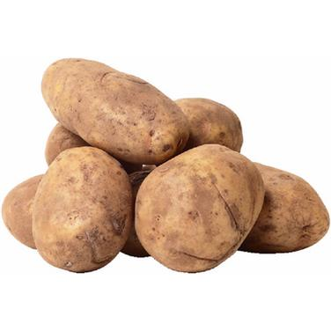
- Keep moist but not wet at all times, especially at flowering time

